**SAT PRACTICE QUESTIONS**

**Question 1**

In the figure below, what is the value of *y* ?

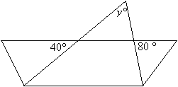

|  |  |
| --- | --- |
| (A)           (B)           (C)           (D)           (E) | 40 50 60 100 120 |

**Question 2**

**Find the values of x and y**

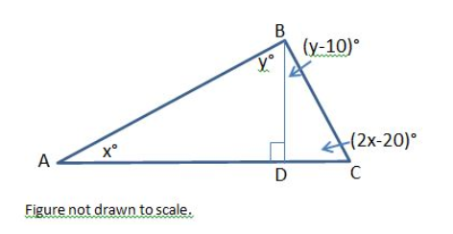

**Question 3**

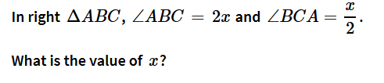

1. **24**
2. **48**
3. **32**
4. **36**
5. **30**

**Question 4**

**Find the value of *x* in the diagram below.**

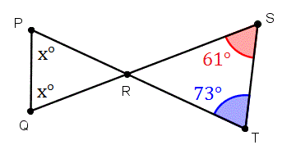

1. **72**
2. **61**
3. **73**
4. **36**
5. **Unknown**

**Question 5**  
Find the value of ***x***.

1. 